# SUPERMARKET AUTOMATION

# DEPARTMENT OF COMPUTER SCIENCE & ENGINEERING

# YEAR: 2020-21

# 5TH SEMESTER

# ( DATA FLOW DIAGRAM )

# SUBMITTED BY:

# Siba Sankar Panda - 1802081062

# Prasenjit Ghose - 1802110011

# Pratyush Ranjan Bohidar - 1802060021

# 

MANAGER

Feedback

Menu

Sales Forecast

VENDOR

Received Goods

Time Worked

Pay

Production Schedule

Payment

Bill Payment

EMPLOYEE

Order

CUSTOMER

Purchase Order

Product Served

**Fig: LEVEL 0 DFD**

EMPLOYEE

Sales Forecast

Product Ordered

CUSTOMER

Customer Order

VENDOR

Received Goods

Product Served

Payment

Production  
 Schedule

Inventory

Order  
 Decisions

Time Worked

Purchase Order

Update product

Payment

Pay

DATABASE

Available Product

Check

Feedback

MANAGER

Menu

**Fig: LEVEL 1 DFD**

CUSTOMER

Customer Order

ORDER

Request for Forecast

Severed Order

Payment

Sales Forecast

PAYMENT

**Fig: 0.1 Sale**

Quantity Used

Quantity Severed

Quantity Produced & Location Stored

Production  
 Schedule

Product Order

Production Data

ORDER

RAW MATERIALS

INVENTORTY

Update Product

**Fig: 0.2 Production**

Check & Update

PURCHASE ORDER

Quantity   
 Received

Payment Approval

Received Goods

Payment

Order Decision

Quantity On-Hand

RAW MATERIALS

RECEIVED ITEMS

VENDOR

**Fig: 0.3 Procurement**

TIME CARDS

Payment

Payment Approval

Unpaid time cards

Payroll Request

Time Worked

Employee ID

EMPLOYEE

PAYROLL

PAYMENTS

**Fig: 0.4 Payroll**

**DATA DICTONARY**

Login Info: User-Id + Password

User Info: User-Id + User-Name + Address

User-Id: Integer

Password: String

User-Name: FirstName + {Middle-Name} + Last-Name

First-Name : String

Middle-Name: String

Last-Name: String

Address: City + State + Pincode

City: String

State: String

Pincode: Integer

Customer-id: integer

Date: year + month + day

Year: integer

Month: integer

Day: integer

Order-info: customer-id +items +quantity +date +time +Payment method+ orderid

Order-id: integer

Time: hour + minute

Hour: integer

Minute: integer

Payment-method: [Card, UPI, Offline]

Card: card-no + CVV

Card-no: integer

CVV: integer

UPI: string

Offline: string

Accepted-order: order

Reject-message: order + message

Pending-orders: customer-id + {items + quantity}

Bill: {item + quantity + price} + total-amount + customer-address + order-id

Material-issue-slip: message + item + quantity + customer-address

Message: string

Inventory: {item + quantity}

Item: string

Quantity: integer

Price: integer

Total-amount: integer

Order delivery status: order-id + status

Status: string

**STRUCTURE CHART**

ROOT

Total Product

Sale Registration

User Registration

Inventory Data

Product Data

Search

Product

Inventory Management

Verify (Register / Login)User

Register-Sales

Sales Details

Login Details

Details Ok

Open Product details

Sales Details

Details Saved

Add to Cart

Login Details

View Product

Buy product

Record Sales Details

Enter Sales Details

Compare In Database

Enter User Details

Give Price

Sent Ack.

Price collected

**UML DIAGRAMS**

1. **USE CASE DIAGRAM:**

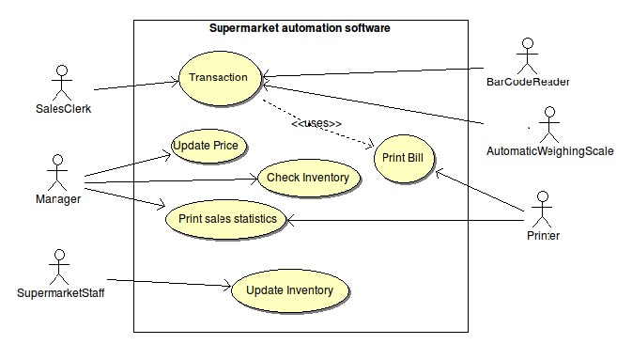

**USE CASE DESCRIPTION:**

**Manager:**

A manager oversees the supermarket's revenue and sales functions. He views the inventory, and review and print the sales statistics.

**Sales clerk:**

The supermarket employs many sales clerks who are responsible for carrying out the transaction with the customers and creating and printing bills for the transactions.

**Supermarket staff:**

They are the supermarket employs, who are responsible for maintenance of the products in the supermarket and addition of newly arrived products to the inventory.

**Perform Sales Transaction:**

Whenever any item is sold from the stock of the supermarket, this function prompts the clerk to pass the item over a bar code reader and an automatic weighing scale, the data regarding the item type and the quantity get automatically registered then. During the sales transaction, the name of the item, code number, quantity, unit price, and item price are entered into the bill. The bill indicates the total amount payable. The inventory is then suitably updated.

**Read Bar code:**

Input: Sold items are passed over the reader.

Processing: Bar code of the item is read and the sold item is registered automatically.

**Weigh:**

Input: Sold items are weighed over the automatic weighing scale.

Processing: Weight of the sold item is automatically registered.

**Generation of the bill:**

A transaction bill containing the serial number of the sales transaction, the name of the items, quantity, unit price, item price and the total amount payable after adding the taxes is printed.

**Update inventory:**

In order to support inventory management, this function updates the inventory whenever an item is sold. Again, when there is a new supply arrival, an employee updates the inventory level by this function.

**Check inventory:**

The manager upon invoking this function issues query to view the inventory details.

**Update prices:**

The manager changes the price of an item by exercising this option.

**Print sales statistics:**

This option generates a printout sales statistics for every item the supermarket deals with.

1. **CLASS DIAGRAM:**

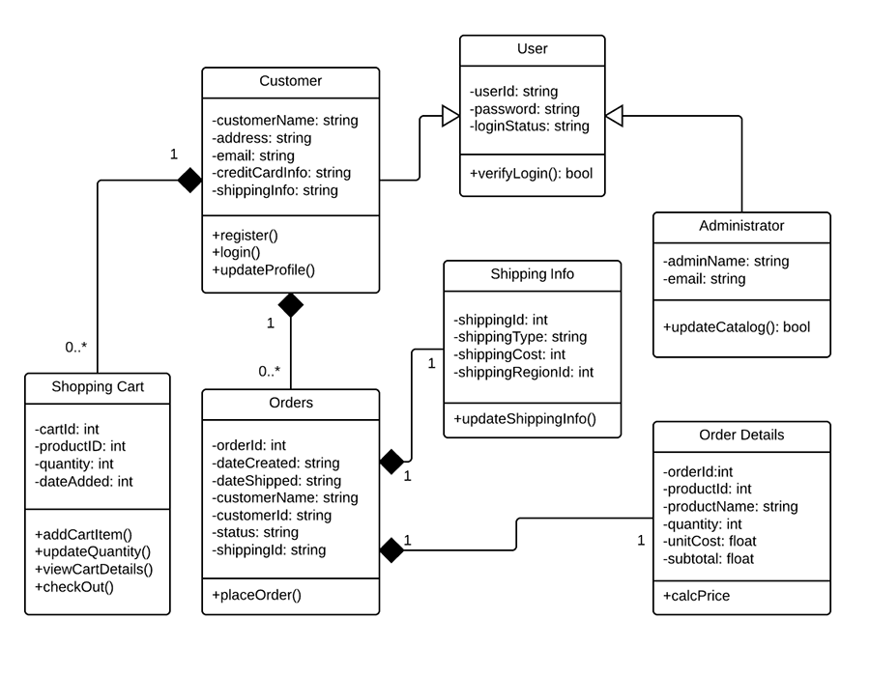

1. **SEQUENCE DIAGRAM:**

**Sequence Diagram – I ADMIN**

a

9: Logout

8: View Profile ()

7:Add Item()

6:AddSubCategory()

5:AddCategory( )

4:Invalid

3:void()

2:Password

1:Username

Admin

Logout

View Profile

Add Items

Add Sub Category

Sign in

Add Category

Admin home Home

**Sequence Diagram – I Customer**

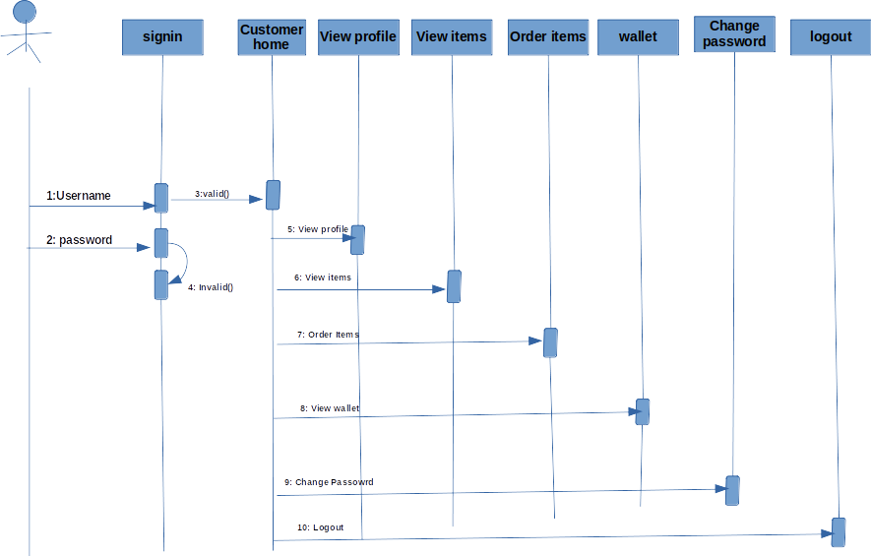

1. **State Chart Diagram**

